

Name:___________________

Mark:________ **/ 43**

**Scientific Method & Practical Skills Mini Quiz**

**Question 1 (8 marks)**

Gertrude noticed that Max was more tired after playing soccer for 45 minutes than he was after a 30 minute game, she concluded that it must be because Max used more energy in a 45 minute game. Max’s Mum noticed that after a 30 minute game Max ate 1500kJ during lunch, while after a 45minute game he ate 2000kJ for lunch. Max’s Mum concluded that Max used 500KJ of energy more playing a 45 minute game than a 30 min game.

|  |
| --- |
| 1. What is the correct name given to the information collected about Max? (1 mark) |

|  |
| --- |
| 1. Was any qualitative data collected? If so what was it? (2 marks) |
|  |

|  |
| --- |
| 1. Was any quantitative data collected? If so what was it? (2 marks) |
|  |

|  |
| --- |
| 1. Once Max’s Mum forgot to measure the amount of lunch Max ate. Also the scales she used were only accurate to 1g (which means 1.6g would show as 2g etc).   Which of these is an error, and which is a mistake. Explain why you made this choice.(3 marks) |
|  |
|  |
|  |

**Question 2 (2 marks)**

One of the eyes in the picture below is in the correct position to take an accurate measurement of the position of the end of the spring.

1. 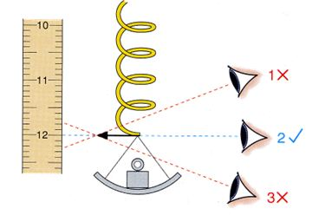Circle the eye in the picture that is in the

correct position (1 mark)

|  |
| --- |
| B. What sort of error could be caused by looking  at the incorrect angle? (1 mark) |

[*http://www.antonine-education.co.uk*](http://www.antonine-education.co.uk)

**Question 3 (6 marks)**

Fill in the blanks on the table (6 marks):

|  |  |  |  |
| --- | --- | --- | --- |
| **Unit of measurement** | Millilitres | Litres |  |
| **Symbol** |  |  | kL |
| **Convert these measurements** | 2500 |  |  |
|  | 6500 |  |
|  |  | 5 |

**Question 4 (7 marks)**

Sarah looked up the nutritional information on a packet of Nutrigrain and discovered that 100g of Nutrigrain provides 1600kJ of energy. She then designed the following table to help her work out how much energy she would get from different amounts of Nutrigrain.

1. Fill in the blanks on Sarah’s table (2 marks):

|  |  |
| --- | --- |
| Amount of Nutrigrain in g | Energy Received in kJ |
| 100 | 1600 |
| 200 |  |
| 250 | 4000 |
| 300 |  |

1. Draw a graph based on the previous information (5 marks) 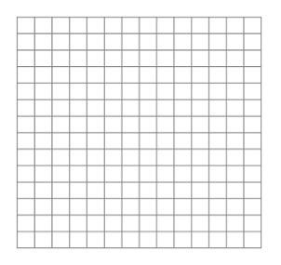

**Question 5 (10 marks)**

Sharif wants to work out how energy efficient the new I pods are compared with the old version. Sharif collects 3 of each version so he has 6 in total. Sharif charges all devices for the same amount of time then counts how many times he can play his favourite song over and over before it stops.

|  |
| --- |
| 1. What is the independent variable (1 mark) |

|  |
| --- |
| 1. What is the dependent variable (1 mark) |

|  |
| --- |
| 1. List one variable Sharif controlled (1 mark) |

|  |
| --- |
| 1. Write a hypothesis for Sharif’s experiment (2 marks). |
|  |

|  |
| --- |
| 1. Was the data collected by Sharif first hand or second hand data (1 mark)? |

1. Complete the following table of Sharif’s results: (2 marks)

|  |  |  |  |  |
| --- | --- | --- | --- | --- |
|  |  | | | |
| **I pod** | **Trial 1** | **Trial 2** | **Trial 3** | **Average** |
| Old | 55 | 60 | 52 |  |
| New | 70 | 60 | 63 |  |

Two things (besides the averages) are missing from the table above. What are they? (2 marks)

**Question 6 (10 marks)**

Identify (name) the following pieces of equipment shown below and state what they are used for:

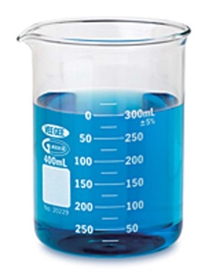(8 marks)

[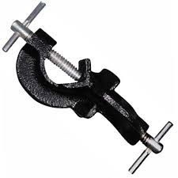](http://www.google.com.au/url?sa=i&rct=j&q=boss+head+clamp&source=images&cd=&ved=0CAcQjRw&url=http://sukm.itrademarket.com/2804211/boss-head-clamp.htm&ei=xRGJVNLPAsXt8AWX5YLQDw&psig=AFQjCNF4xCUYw67jI27-W9P2Y7q2222M1Q&ust=1418355519492137)

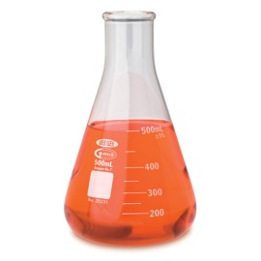

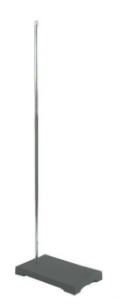

[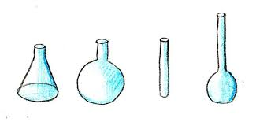](http://www.google.com.au/url?sa=i&rct=j&q=scientific%20equipment%20drawings&source=images&cd=&cad=rja&uact=8&ved=0CAcQjRw&url=http://www.wikihow.com/Draw-a-Scientific-Equipment&ei=VhCJVMqjKqW2mQW2yIH4Dg&psig=AFQjCNGHjHftt7e6Uc_wmIb7BciKR0JRQA&ust=1418355128761877)If you were a teacher marking scientific diagrams drawn by your students what comments could you make about the drawings below? (2 marks)

**End of Test**